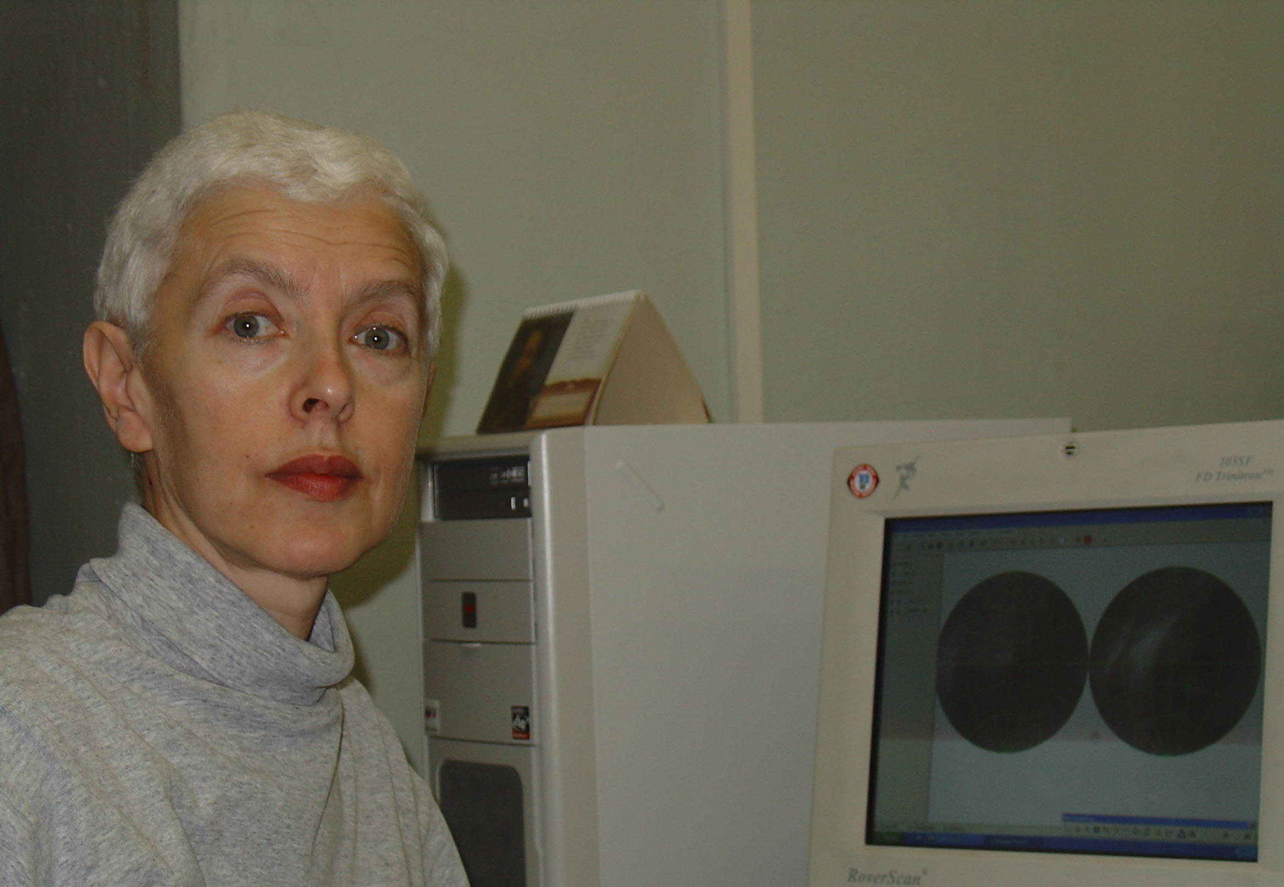
Maria E. Fleis, Institute of Geography, Russian Academy of Science, graduated from Moscow State University, Faculty of Mechanics and Mathematics in 1971, works in cartography since 1980. The developer of the block of coordinate calculations for map transformations in the GIS software GeoGraph GIS 2.0.

Kira B. Shingareva, professor at Moscow State University for Geodesy and Cartography, a principal scientist of Planetary Cartography Laboratory, was graduated from Technical University Dresden at 1961, Ph.D at 1974, Dr.of Sci, at 1992, was busy at the Lab. of Comparative Planetology at the Institute of Space Researches by Academy of Science till 1977, then at the University, participates in the National Space program by mapping the Moon, Mars, Phobos, Venus since 1965, author of more than 150 publications, among them “Atlas of Terrestrial Planets and their Moons”, “Space Activity in Russia – Background, Current State, Perspectives”, co-chairman of ICA Planetary Cartography Working Group 1995-1999, chairman of ICA Planetary Cartography Commission 1999-2003, managed such projects as Series of multilingual maps of planets and their moons, Glossary on planetary cartography, specialized map-oriented DB on planetary cartography in the frames of commission activity.

CARTOGRAPHIC PROJECTIONS FOR SMALL BODIES OF THE SOLAR SYSTEM.
Maria E. Fleis (maria@geocnt.geonet.ru), Michael M. Borisov (bom@geocnt.geonet.ru), Institute of Geography, Russian Academy of Science, Moscow, Russia
Michael V. Alexandrovich (m-indigo@yandex.ru), Moscow State University, Geographical faculty, Moscow, Russia
Philip Stooke (philatwestern@hotmail.com), University of Western Ontario, Western Ontario, Canada
Kira B Shingareva (Kira.Shingareva@mtu-net.ru) Moscow State University for Geodesy and Cartography, Moscow, Russia

First, spherical or near-to-spherical models were used for celestial bodies mapping. It was suitable for the Earth, the Moon, Mars and other large bodies. Many small celestial bodies are of quite irregular shape, and their minimum and maximum radii differ by more than ten per cent. The Morphographic projection was developed for mapping of such worlds [1]. This projection transfers spatial data directly from physical surface to the map plane and shows the body’s shape. A different approach consists of using a triaxial ellipsoid as a mathematical surface for primary data transfer from physical surface. Different cartographic projections were devised for this ellipsoid [2]. A triaxial ellipsoid composed projection, devised for the Phobos map, was later used with morphographic projection for the Deimos map [3].
But some small bodies have an essentially regular shape combined with an unusual revolution axis position, apparently as a consequence of the bodies’ random impact history. Asteroid 433 Eros has a shape similar to an ellipsoid of revolution, but the proportion between major and minor axes and ellipsoid revolution axis position differs from conventional ones. The revolution axis of this ellipsoid is perpendicular to the revolution axis of the body (the ellipsoid is prolate), so Eros could be considered a triaxial ellipsoid with equal polar and intermediate radii. But an attempt to use a triaxial ellipsoid composed projection for an Eros map showed that the projection is not suitable for this celestial body (fig. 1). The reason is that the major axis is more than twice longer than the minor one, so eccentricity, conventionally used as a small value in a series, is closer to 1 than to zero.

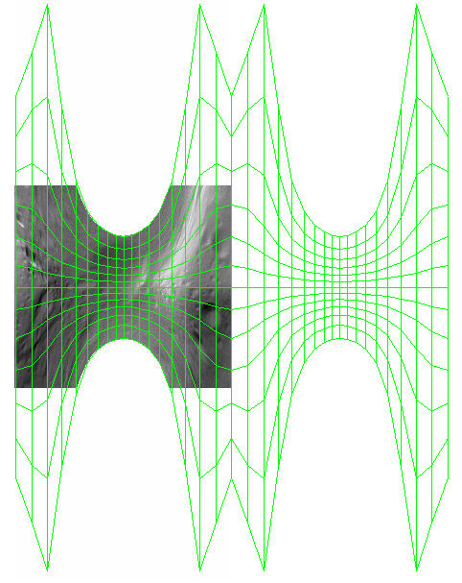

60° N
0°
60° S
90° W
180° W
270° W
0°
Fig.1. Graticule and fragment of Eros’ raster image on Bugaevsky cylindrical projection for triaxial ellipsoid.
We propose two conformal projections of “upturned” ellipsoid of revolution: Transverse Cylindrical and Transverse Azimuthal. They may be used for creating a composed projection. The Azimuthal projection itself provides a representation of the whole surface of the body.
The following symbols are used in formulae:
- semimajor axis of ellipse (for Eros asteroid we assume it to be 33000 m)
- semiminor axis of ellipse (for Eros asteroid we assume it to be 13000 m)
- eccentricity of ellipse
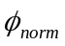 - planetocentric latitude in normal aspect
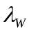 - longitude west of zero meridian
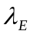 - longitude east of zero meridian
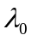 - longitude of the center of projection;. 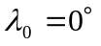 or 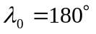
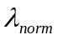 - longitude east of the center of projection
- angular distance from the center of projection
- azimuth as an angle measured clockwise from the north
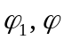 - latitude at traditional ellipsoid of revolution and at “upturned” one
- longitude at “upturned” ellipsoid of revolution
 - radius of latitude circle on Azimuthal projection (transverse graticule)
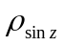 - divided by 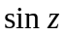
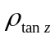 - divided by 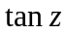
- radius of the Equator of transverse graticule on Azimuthal projection under condition of no distortion in the center of projection
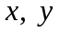 - rectangular coordinates ( - horizontal, 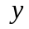 - vertical)
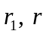 - radius of parallel curvature for traditional ellipsoid of revolution and at “upturned” one
 - radius of meridian curvature
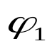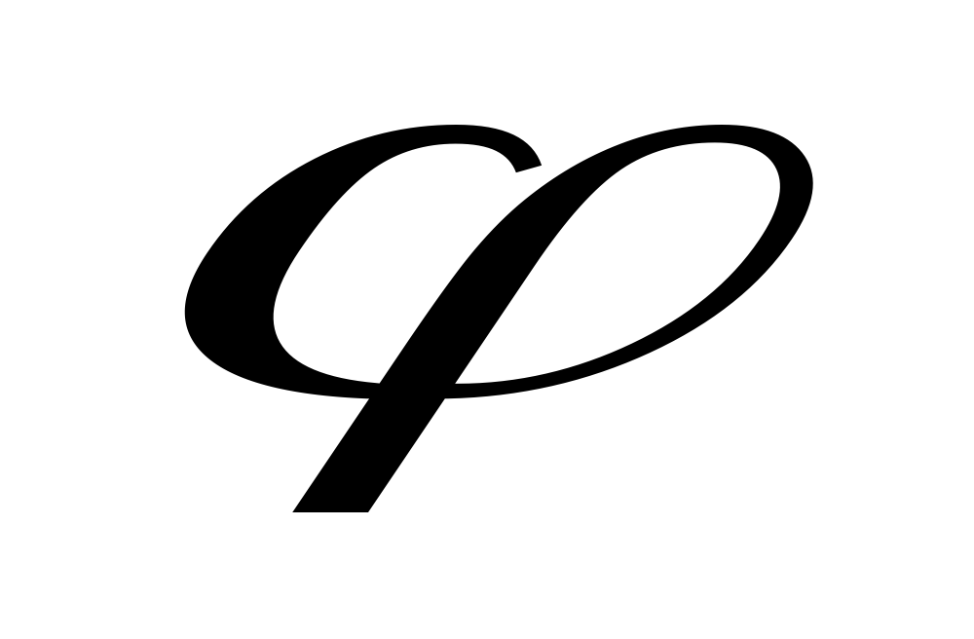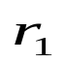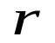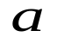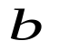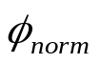Fig.2. Ellipsoid of revolution section by zero meridian plane.

From the known formulae based on geometric properties of ellipse (fig. 2)
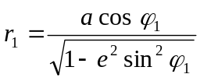, 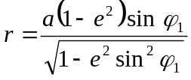, 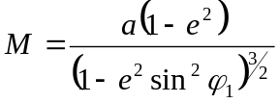

we obtain formulae for radius of parallel and meridian curvature at “upturned” ellipsoid of revolution:
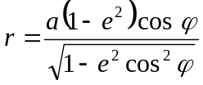 , 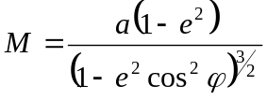
Let’s derive formulae of the new Conformal Cylindrical projection for the case of matching ellipsoid revolution axis with major (not minor, as usual) axis of ellipse.
Conformality gives us the equality of relative scale factors along a parallel and along a meridian in a point with latitude and longitude:
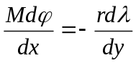
Since 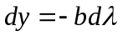 (for a tangent cylinder) and 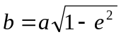, we get:
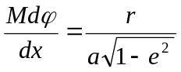

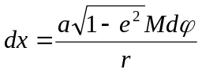

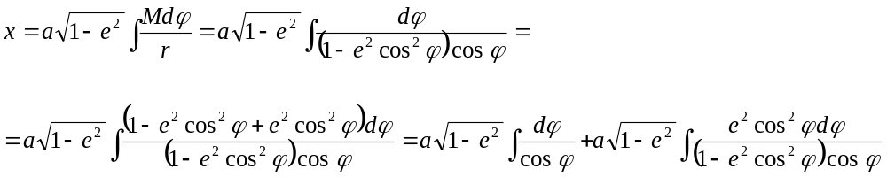
The first integral is the same as one used in conformal cylindrical projection derivation for traditional ellipsoid:

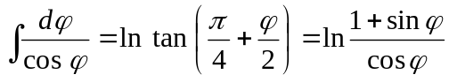

The second integral, defining the deviation of ellipsoid from sphere, is not traditional:

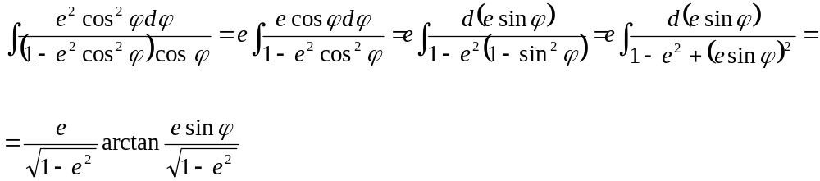

Thus
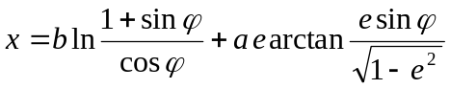
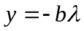

Since longitude and latitude for celestial bodies are usually defined in planetocentric coordinate system [4], it’s possible to transform datasets from normal to transverse coordinate system using known formulae:
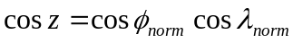
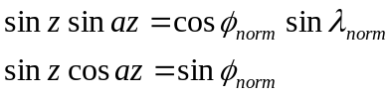
Angular distance from the center of projection and latitude 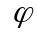 at “upturned” ellipsoid of revolution are linked by the formula
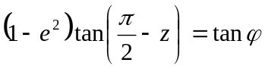 , which is similar to traditional one linking geodetic and geocentric latitude 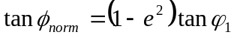
Azimuth and longitude at “upturned” ellipsoid of revolution relate as 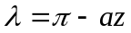
Final formulae look like:

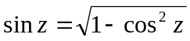
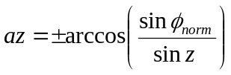
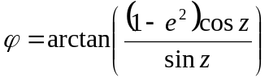
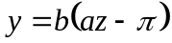
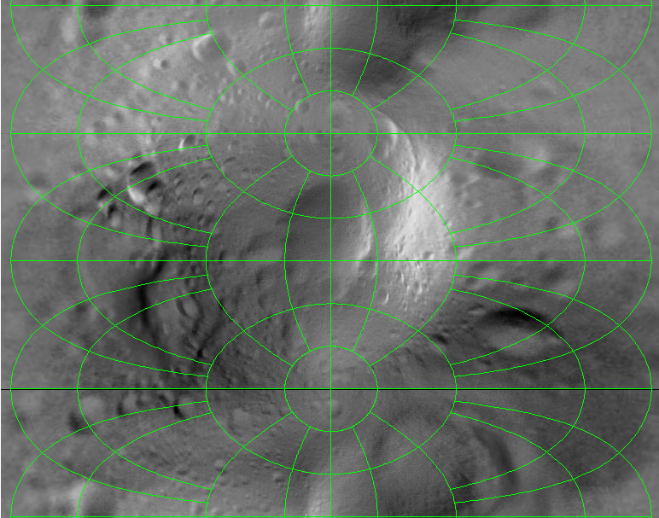
180° W
350° W
330° W
60° S

30° S
10° S
5° S
0° W
270° W
180° W
5° W
10° W
30° W
60° W
60° N

30° N
10° N
5° N
0° N
0° N
355° W
90° W
0° N
Fig.3 Eros asteroid map on presented Cylindrical projection.
90° N
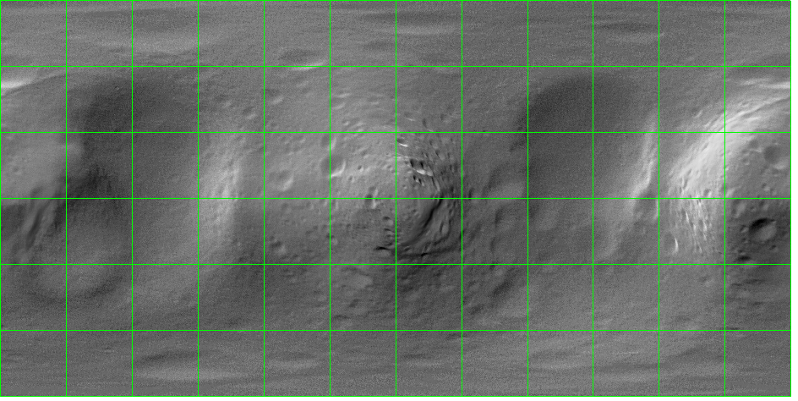
0°
90° S
90° W
180° W
270° W
0°

Fig.4 Eros asteroid map in longitude/latitude coordinates
Let’s now derive formulae of the Conformal Azimuthal projection for the “upturned” ellipsoid of revolution. Conformality gives us the equality of relative scale factors along a parallel and along a meridian in a point with latitude :
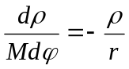

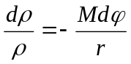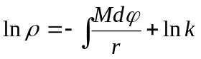

Since the integral is the same as for the Cylindrical projection, we obtain:
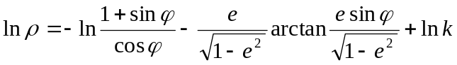

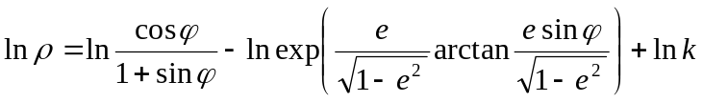

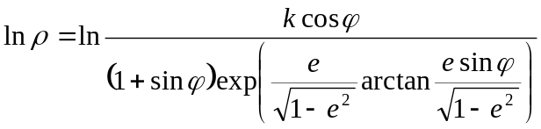

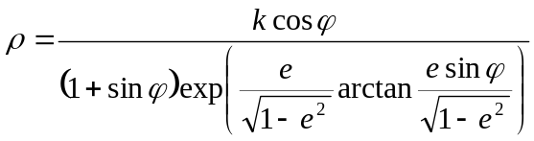

The constant is defined from the condition of no distortion in the center of projection

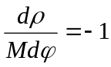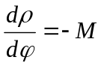

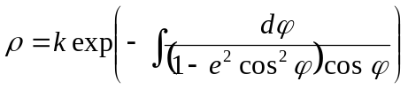

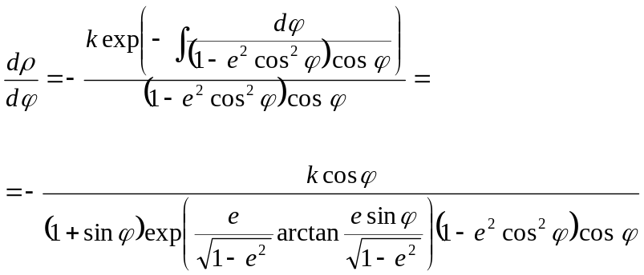

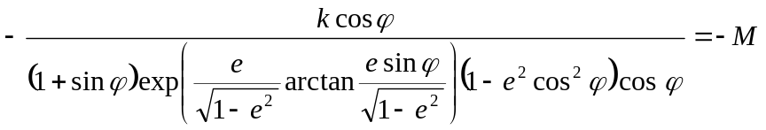

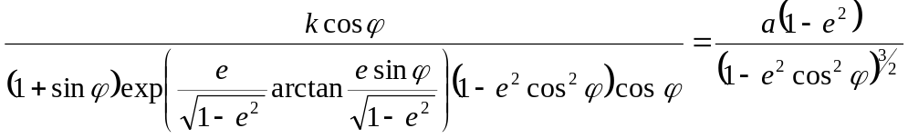

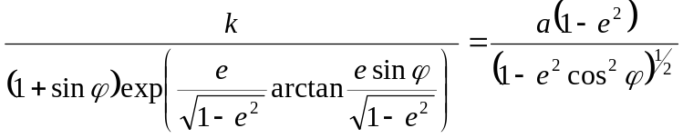

Substitution of 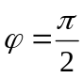 gives us:

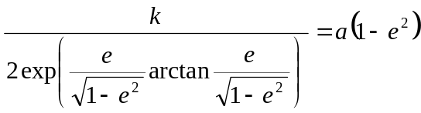

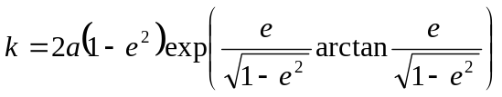
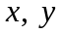 are calculated using standard formulae for Transverse Azimuthal projection:
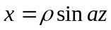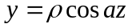

Final formulae look like:
Two sets of formulae are necessary to exclude singularities while 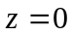 and 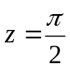.
The first variant:
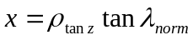, 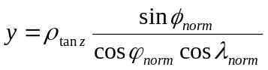,
where 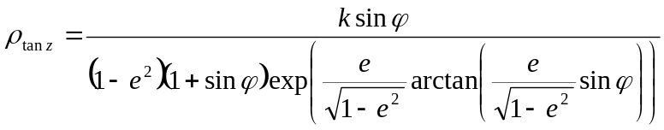,
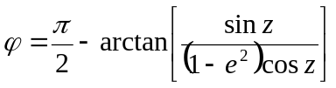

The second variant:
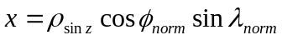, 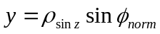
where
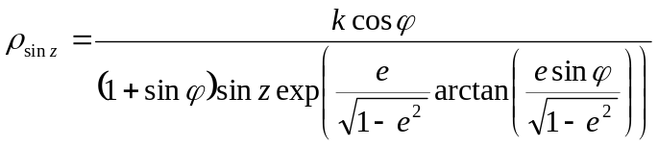, 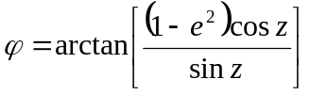
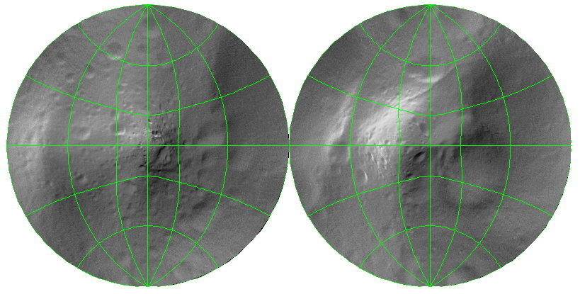
90° W
W
180° W
W
0°
W
60° W
W
120° W
W
240° W
W
270° W
W
60°N
W
30°S
W
0°
W
Fig.5 Eros asteroid map on presented Azimuthal projection.

The formulae are obtained without approximations and are true even for eccentricity close to 1. The derivation of similar formulae for equal-area projections is based on the following integral calculation
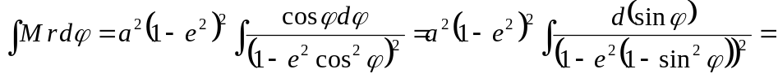
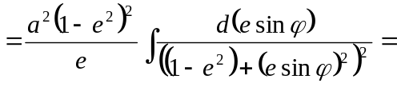
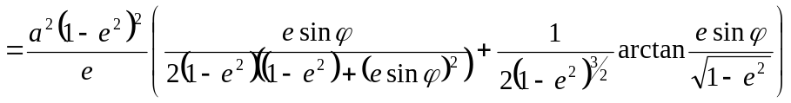

Approximate formulae of equidistant projections need serious revision. Formulae of obtained projections and JavaScript application for calculation of rectangular coordinates of point sets on these projections are published on the Web. They are available at http://geocnt.geonet.ru/rus/prjastr.html or http://geocnt.geonet.ru/en/prjSmallBody.html

References:
- Stooke, P.J. and Keller C.P. Map projections for non-spherical worlds: The variable –radius projections. Cartographica 27, 1990, 82-200.
- Бугаевский Л.М. К вопросу о получении изометрических координат и равноугольной цилиндрической проекции трехосного эллипсоида. Изв. Вузов. Геодезия и аэрофотосъемка, №4, 1997, с. 79-90.
- Shingareva, K.B., Krasnopevtseva, B. V., Leonenko, S.M. Fleis, M.E., Buchroithner, M.F., Waelder, O. and Stooke, P. Phobos and Deimos – A New Map in the Series of Multilingual Relief Maps of Terrestrial Planets and Their Moons. Proceedings of XXI Intern. ICA Conference, Spain (July 2005, La Coruna).
- Duxbury T.C. and Callahan J.D. Phobos and Deimos control neworks, Icarus 77, 1989, 275-86.

